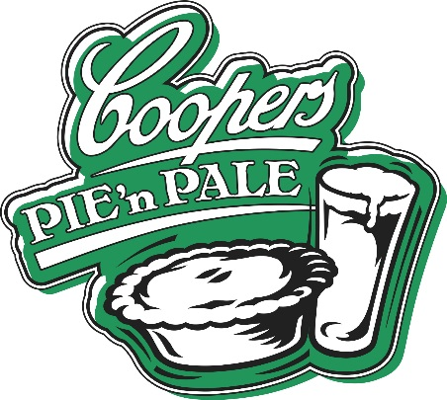

Winning pies, not humble pies.
Despite always having a fondness for pies, I have never really thought much about them. I have always thought a lot about beer, but never about pies.
Like beer, pies are something that you can think a lot about or next to nothing, and the result is still the same. What really matters is if you like it.
However, this would be a very short article if I simply concluded my month of eating pies by telling you simply which one I liked most. Instead, I will share a few of the things I noted during the Sydney’s Good Food Month.
Firstly, as with most areas of eating and drinking, pies are very subject to fashion and trends. It is quite rare to have a meal served on a plain white plate any more. Slate tiles and wood slabs abound, and the wood paddle in particular seemed to be a favourite with pubs for serving pies. It’s the perfect platform too, being able to accommodate a pie and accoutrements and sides while presenting the pie beautifully.
The definition of a pie is very wide as well. From the all pastry, hold-in-your-hand number through to pot pies in which a bowl of filling is covered with pastry. Shepherds pies, cottage pies and flans were included and the range of fillings was huge, covering just about every common meat filling and casserole style. About the only constant was the Coopers Pale Ale that each was served with.
In the end, the top handful were a spread of flavours and styles and the only thing uniting them was that across the judging criteria – flavour, originality, presentation and the presentation of the Coopers – they were universally strong.
There was a tie for third place. The Rag & Famish Hotel presented cassoulet pie featuring slow-cooked casserole with haricot beans, pork, Toulouse sausage and confit duck. It was the first pie that I tried and straight away I knew that competition was going to be fierce. It was much more than the ‘humble pie’ but a fine casserole that happened to be encased in light pastry.
The Rag shares the bronze with the Empire Hotel Annandale. A Braised lamb shank in Coopers Pale Ale pie served with salsa verde and creamy mash, the pie was a fashionable twist on a classic theme. It was served with - and well matched to - a beautifully presented Coopers Pale Ale.
Second place went to The Lord Roberts for its excellent Goat Pie and rice chips. There was no single element that stood out with the Lord Roberts, it was just a pie that ticked every box in a venue that was a pleasure to visit. If a pie typified “you just know a good pie when you have it” this was it.
The winner was a surprise and a stand out. The Parkside Diner, Bat & Ball Hotel served up a Tijuana short rib pie. While drawing on the highly fashionable Mexican/Barbeque/Ribs trend that has almost been overdone, the Parkside Diner made its pie fresh and interesting and original. It stood out amidst the 33 pies I enjoyed during the month.
Congratulations to all of the pubs who got involved. The enthusiasm with which most approached the competition and engaged their staff and their patrons really marked them out as great pubs. For all of the pies that were consumed during the month, it was getting to visit so many great pubs that was the highlight.

